F-15 TCP
WORLDWIDE REVIEW
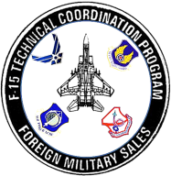
CONFERENCE CRITIQUE
NOVEMBER 2016

1. Did you find the conference to be advantageous?

2. Were there any aspects of the conference that you felt were unnecessary?

3. List any items that you would like to be included in future conferences that were not included in this conference.

4. What would you suggest to the TCP to improve future conferences?

5. How did you feel about the conference location? Where would you like to see future conferences held?

6. What services provided by the TCP do you feel need improvement?

7. Evaluate the overall quality and content of the conference, 1-10, with 10 being excellent.

8. Additional comments:

Please e-mail the critique sheet to Sheree.Quattlebaum@us.af.mil.
Thank you for your participation

