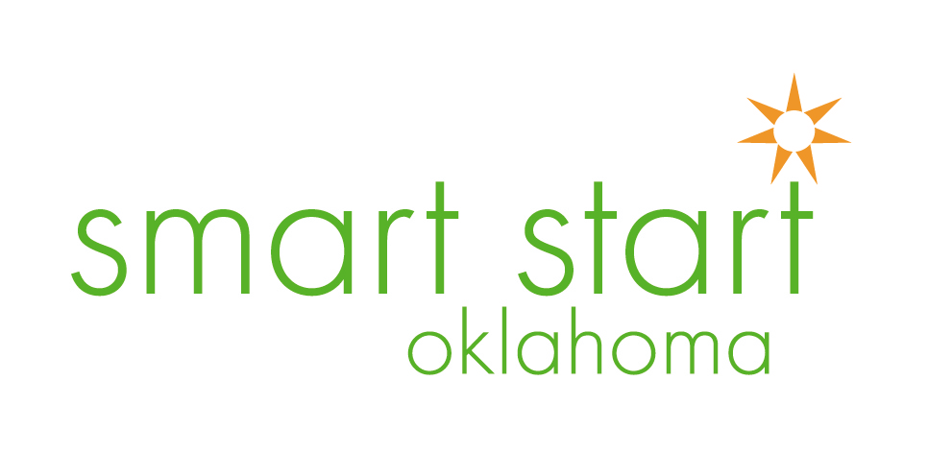
Debra Andersen, Executive Director
Oklahoma’s Pre-kindergarten History
Debra.andersen@smartstartok.org

