Date

Click here to enter text.
Click here to enter text.

Click here to enter text.
Click here to enter text.

Dear: Click here to enter text.,

This is to extend an official invitation for you to attend and participate in the 54TH Annual Meeting of the International Association of Movers to be held October 21-24, 2016, at Hyatt Regency, New Orleans, Louisiana.

The International transportation of household goods and personal effects are the main concerns that will be addressed. Since your company is a registered member of this Association, your experience in this field will allow you to make a significant contribution to this meeting, where representatives from the United State and 170 other countries will be present.

It is our sincere wish that you can join us at the Hyatt Regency, New Orleans, Louisiana.

Sincerely,

International Association of Movers

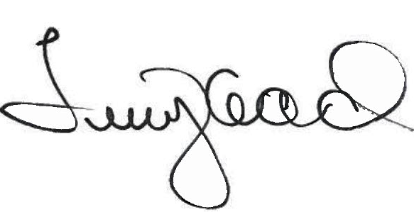
Terry R. Head, CAE, CMC
President
International Association of Movers (IAM)
