CONTACT
Naomi Iheme
Events and Sponsorships
Goodwill Industries International
Direct: (240) 333-5345
Fax: (301) 258-0578
naomi.iheme@goodwill.org

2016 Sponsorship and exhibitor prospectus

Table of Contents

Align Your Business with the Goodwill® Brand 3
Sponsoring Goodwill Events 4
Profile of 2016 Goodwill Industries International Sponsorable Events 4
Benefits of Sponsoring Goodwill Conferences 5
Types of Sponsorships 6
Sample of 2015 Sponsors 7
What You Need to Know to Sponsor 8
Sponsorship Application Procedures 8
Sponsorship Reservation Deadlines* 8
Benefits of Exhibiting at Goodwill Conferences 9
Profile of 2016 Goodwill Industries Internaitonal Exhibits 10
What You Need to Know to Exhibit 11
Exhibits Terms and Conditions 12

Align Your Business with
the Goodwill® Brand
GOODWILL’s MISSION
Goodwill works to enhance the dignity and quality of life of individuals and families by strengthening communities, eliminating barriers to opportunity and helping people in need reach their full potential through learning and the power of work. Goodwill is
- The second largest nonprofit organization in the United States.
- Number 19 of America’s top 25 inspiring companies (Forbes).
- One of the nation’s top five most valuable and recognized nonprofit brands (Cone LLC).
- 164 member organizations with more than 3,076 stores and 125,800 employees.

Goodwill Industries International (GII) holds five conferences annually, bringing together hundreds of Goodwill® professionals from across the United States and Canada who seek to improve their operations, lobby for government support and advance the Goodwill mission.
By sponsoring Goodwill events or exhibiting at the tradeshows, companies increase their exposure, secure exclusive access to Goodwill decision makers and ultimately increase revenue.

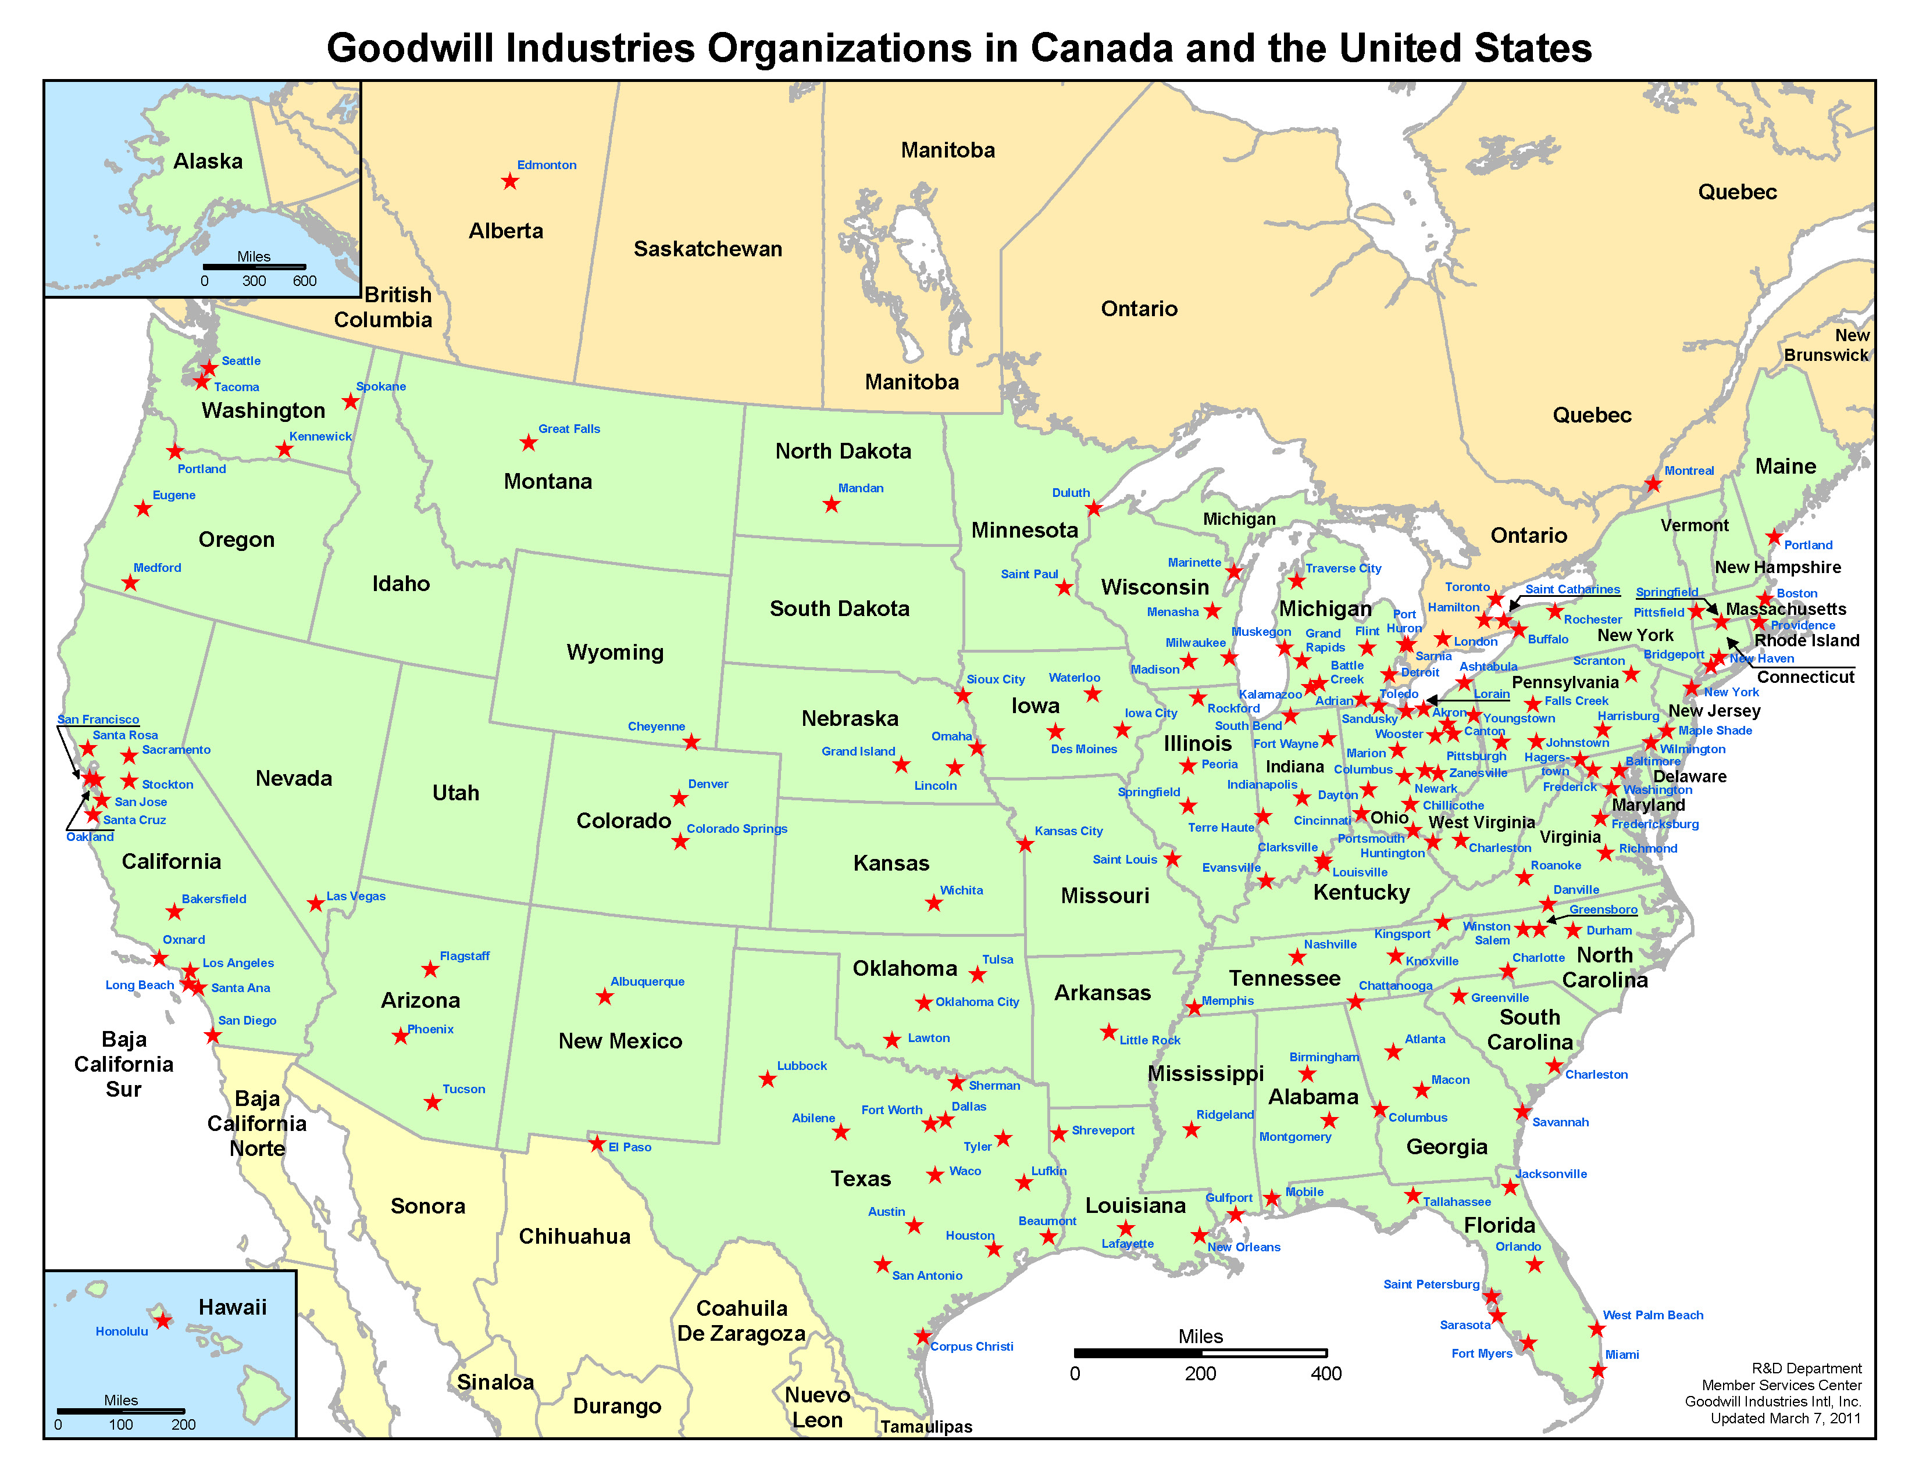

SPONSORING gOODWILL EVENTS

Profile of 2016 Goodwill Industries International SPONSORABLE Events
Event | Conference of Executive (COE) | Spring Conference (Spring) | Delegate Assembly  (DA) | Summer Conference and Marketplace Tradeshow (Summer) | Goodwill Loss Prevention and Safety (GILPS)
Attendees | 200 | 450 | 400 | 500 | 150
Attendee Profile | - C-Levels  - Executive Development Program Participants | - C-Levels  - Senior Management  - Mission Advancement  - Resource Development  - Human Resources | - C-Levels  - Board Members | - C-Levels  - Senior Management  - Mid Level Management  - Business Development  - Retail  - Finance  - Information Technology  - Marketing  - Contracts | - C-Levels  - Senior Management  - Mid-level Management  - Loss Prevention  - Safety  - Insurance  - Legal  - Information Technology  - Human Resources
Attendee Highlight | Key Influencers | Decision Makers | Key Influencers | Key Influencers  Decision Makers | Influencers  Decision Makers
2016 | February 7–9  Scottsdale, AZ  Hotel Valley Ho | May 15–18  Indianapolis, IN  Marriott Indianapolis Downtown | June 11–13  Omaha, NE  Hilton Omaha | August 7–10  Minneapolis, MN  Hyatt Regency Minneapolis | November 2016  Phoenix, AZ  Tempe Mission Palms

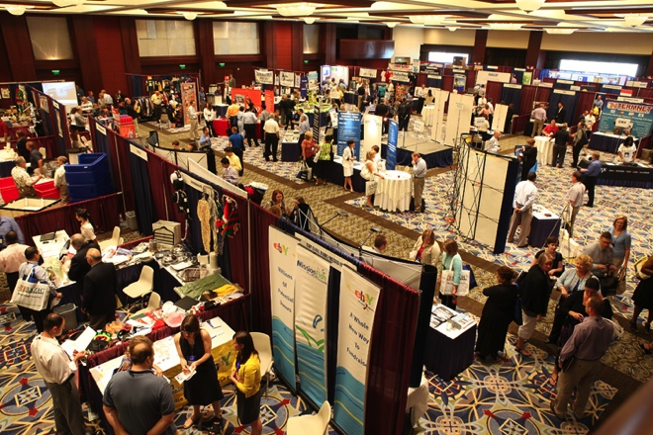
Benefits of SPONSORING Goodwill ConferenceS

Build Relationships and
Market Your Organization
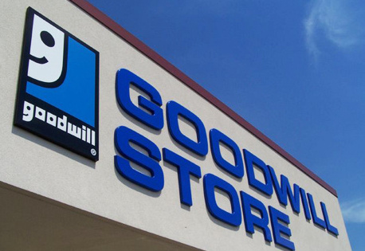
By sponsoring Goodwill conferences, you participate in valuable networking opportunities that allow you to personally introduce yourself to potential customers, build upon your standing relationships, demonstrate industry innovations and distribute samples of your products. Additionally, sponsorship of Goodwill conferences is the only way to network with Goodwill’s C-level staff.

Align with the Goodwill Brand
When you work with Goodwill, you form a bond with the second largest nonprofit organization in the United States, one of America’s top 25 inspiring companies (Forbes) and one of the nation’s top five most valuable and recognized nonprofit brands (Cone LLC). Aligning with such a powerful brand and household name allows your organization to expand its sales revenue and reach audiences it may otherwise leave untapped.

Change Lives
Partnering with Goodwill makes great business sense and helps improve the lives of people in the communities where you live and work. Goodwill generates opportunities for people to achieve economic stability and build strong families and vibrant communities by offering job training, employment placement services and other community-based programs for people who have disabilities, those who lack education or job experience, and individuals who face other challenges to gaining and maintaining employment. By working with Goodwill, you help create jobs.

Types of Sponsorships
- Annual sponsorships
- Event à la carte sponsorships
- Campaign sponsorships
- In-kind support sponsorships at events
To indicate interest in sponsorships, please email naomi.iheme@goodwill.org.

Annual Sponsorships
Annual sponsorships offer year-long benefits and provide the highest level of exposure for organizations seeking to work with Goodwill and its 165 community-based members. Annual sponsorship packages vary depending on sponsorship level. Confirmations of annual sponsorships are subject to a GII internal committee vetting process and sponsorship terms are guided by a sponsorship contract. Annual sponsorships include:
- Presence at five GII conferences.
- Speaking opportunities at events. (Limited to Platinum, Gold and Silver sponsorship levels only.)
- Exclusive access to event attendees via entertainment events, VIP seating and introductions.
- Prime tabletop or booth locations at GII conference exhibits.
Platinum | Gold | Silver | Bronze
5 Events | 5 Events | 5 Events | 5 Events
$50,000 | $30,000 | $20,000 | $10,000

Event À La CARTE Sponsorships
Event sponsorships are designed for organizations interested in specific event exposure. Opportunities are conference specific and are limited in number. More opportunities may become available closer to the event. For the most updated list of event sponsorship opportunities, detailed descriptions, pricing, and ad specifications and deadlines, email naomi.iheme@goodwill.org.
Conference of Executives | Spring Conference | Delegate  Assembly | Summer  Conference | Goodwill Loss Prevention and Safety
Speaker  Sponsorship | Speaker Sponsorship | Speaker  Sponsorship | Speaker  Sponsorship | Speaker  Sponsorship
Golf  Sponsorship | Head Shot Sponsorship | Golf  Sponsorship | Head Shot  Sponsorship | Head Shot  Sponsorship
Hotel Room  Bag Drop | Hotel Room  Bag Drop | Hotel Room  Bag Drop | Hotel Room  Bag Drop | Hotel Room  Bag Drop
Welcome  Reception | Welcome Reception | Welcome  Reception | Welcome  Reception | Welcome  Reception
General Session Commercial | General Session Commercial | General Session Commercial | General Session Commercial | General Session Commercial
Digital Screen Commercials / Ads | Digital Screens Commercial / Ads | Digital Screen Commercials / Ads | Digital Screens Commercial / Ads | Digital Screens Commercial / Ads
 | Dine Around Sponsorship |  |  | Dine Around Sponsorship

Campaign sponsorships
Sponsors can gain visibility by participating in GII campaigns (business area strategic initiatives) that offer targeted visibility. Campaigns vary from year to year and are often available on short notice.

In-kind Support Sponsorships at Events
These opportunities provide organizations with access or exposure to event attendees in exchange for the provision of in-kind support at any or all Goodwill events, as mutually agreed upon by GII and the organization. GII offers both standard and custom in-kind packages. The GII sponsorship agreement guides in-kind sponsorships.

SAMPLE OF 2015 Sponsors
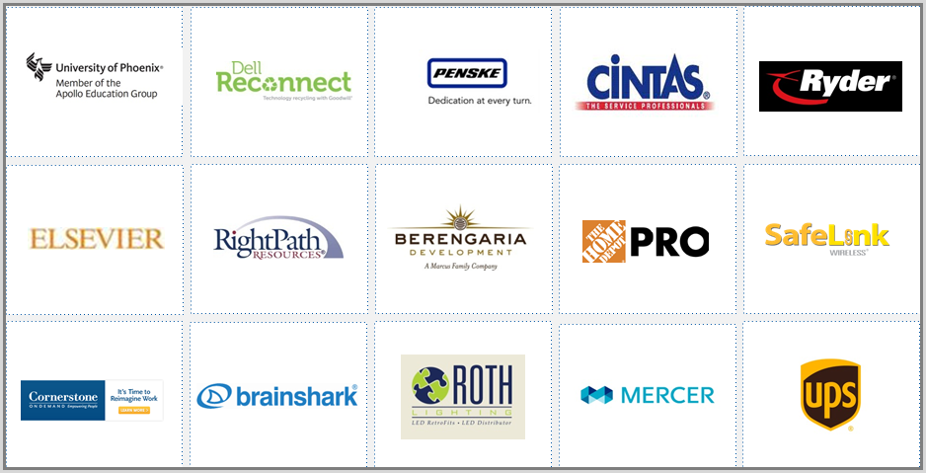

Goodwill Industries International (GII) provides sponsorship, partnership, vendor and tradeshow opportunities to organizations that have goods and services that may benefit Goodwill member agencies. Each Goodwill agency operates independently and makes its own purchasing decisions. An organization’s affiliation as a sponsor, partner, vendor or tradeshow exhibitor with GII does not imply that GII favors one company over another. Goodwill® and Goodwill Industries® are registered trademarks of Goodwill Industries International, Inc. Other product and company names mentioned herein may be the trademarks of their respective owners.

WHAT YOU NEED TO KNOW TO SPONSOR

Sponsorship Application Procedures

Sponsorship Reservations
- Interested companies should fill out a Sponsorship Request Form and email naomi.iheme@goodwill.org.

Sponsorship Processing
- Sponsorships are reserved on a first-come, first-served basis.
- Confirmations of sponsorships are subject to GII’s internal vetting process and a third-party screening process.
- All sponsors must agree to abide by GII sponsorship terms and conditions by reviewing and signing a GII sponsorship agreement. This agreement is not subject to change.

Payment
- Annual sponsorship payments may be made in three installments or all at once.
- Event à la carte and campaign sponsorships payments are due in full once reserved.

Cancellations
- Cancellations to already reserved sponsorships must be received in writing by the dates listed below.
- No refunds or cancellations will be permitted beyond the dates listed.

Advertising Specifications
- Review the ad specifications page for ad guidelines and due dates.

Sponsorship Reservation Deadlines*
January 15, 2016 COE Conference sponsorship reservation closes.
April 15, 2016 Spring Conference sponsorship reservation closes.
May 15, 2016 Delegate Assembly Conference sponsorship reservation closes.
July 15, 2016 Summer Conference sponsorship reservation closes.
September 30, 2016 Goodwill Industries Loss Prevention and Safety Conference event sponsorship reservation closes.
*Dates subject to change.

Benefits of exhibiting at Goodwill ConferenceS

Build Relationships and Market Your Organization

- Introduce your organization to Goodwill's decision-making or influencers from the local Goodwill agencies.
- Network with 500 – 550 Goodwill employees from 164 independent Goodwill agencies, representing more than 3,000 Goodwill retail stores in the United States and Canada.
- Connect with target attendees relative to your business.
- Increase your return on investment with custom exhibitor marketing and sponsorships for every budget.
- Exhibit with your industry peers.

Profile of 2016 Goodwill INDUSTRIES iNTERNATIONAL ExhibitS
Event | Spring Conference | Summer Conference Marketplace Tradeshow | Goodwill Industries®  Loss Prevention and Safety (GILPS)
Attendees | 450 | 500 | 150
Attendee Profile | - C-Levels  - Senior Management  - Mission Advancement  - Resource Development  - Human Resources | - C-Levels  - Senior Management  - Mid-Level Management  - Business Development  - Retail  - Finance  - Information Technology  - Marketing  - Contracts | - C-Levels  - Senior Management  - Mid-Level Management  - Loss Prevention  - Safety  - Insurance  - Legal  - Information Technology  - Human Resources
2016 Dates | May 15–18  Indianapolis, IN  Marriott Indianapolis Downtown | August 7–10  Minneapolis, MN  Hyatt Regency Minneapolis | November 2016  Phoenix, AZ  Tempe Mission Palms
Exhibit Hours | Session Networking Breaks  Networking Lunch | 12–3 p.m. each day | Session Networking Breaks  Networking Lunch
Exhibit Type | Tabletop | 8x10 Booth | Tabletop
Exhibit Costs | $2,000 | $3,000 (Standard)  $3,500 (Premium)  $5,500 (Double) | $1,500
Registration Open* | March 15 (Updated) | April 15 (Updated) | July 15 (Updated)
Registration Deadline | May 1st (Updated) | July 15 | October 15
Payment Term | Credit card only | Credit card only | Credit card only
Cancellation Terms | $100 fee prior to deadline  No refunds after deadline | $100 fee prior to deadline  No refunds after deadline | $100 fee prior to deadline  No refunds after deadline

Note – Registration dates are subject to change.

What You Need to Know to Exhibit

EXHIBIT Application Procedures
- Exhibit registration must be completed online.
- All registering organizations will be subject to a review process by GII. Review criteria include:
- Organization must be incorporated in the United States or Canada.
- Organization’s records must be verifiable with public tools such as Dun and Bradstreet, LexisNexis or otherwise.
- During registration, all exhibitors must upload the following:
- A valid certificate of insurance. See insurance requirements details below.
- Current company logo in jpeg and eps format.

Insurance Requirements
- All certificates will be reviewed for authenticity and coverage periods.
- Non-compliant organizations will not be able to secure a booth space.
- The minimum liability limits required are as follows:
- Comprehensive general liability insurance endorsed to include products and completed operations and contractual liability in a minimum amount of a $2,000,000 combined single limit.
- All such policies shall specifically state: "Goodwill Industries International is named as additional insured under above policies:"
- Each policy shall state that it may not be canceled or changed without at least 10 days' prior written notice to GII.
- Certificates should be mailed to: Goodwill Industries International, Attention: CFO, 15810 Indianola Drive, Rockville, MD 20855.

Exhibitor Responsibilities
- Compliance with Exhibit Terms and Conditions
- Provision of a valid certificate of insurance (COI) during booth online registration
- Tabletop/Booth Wireless Access
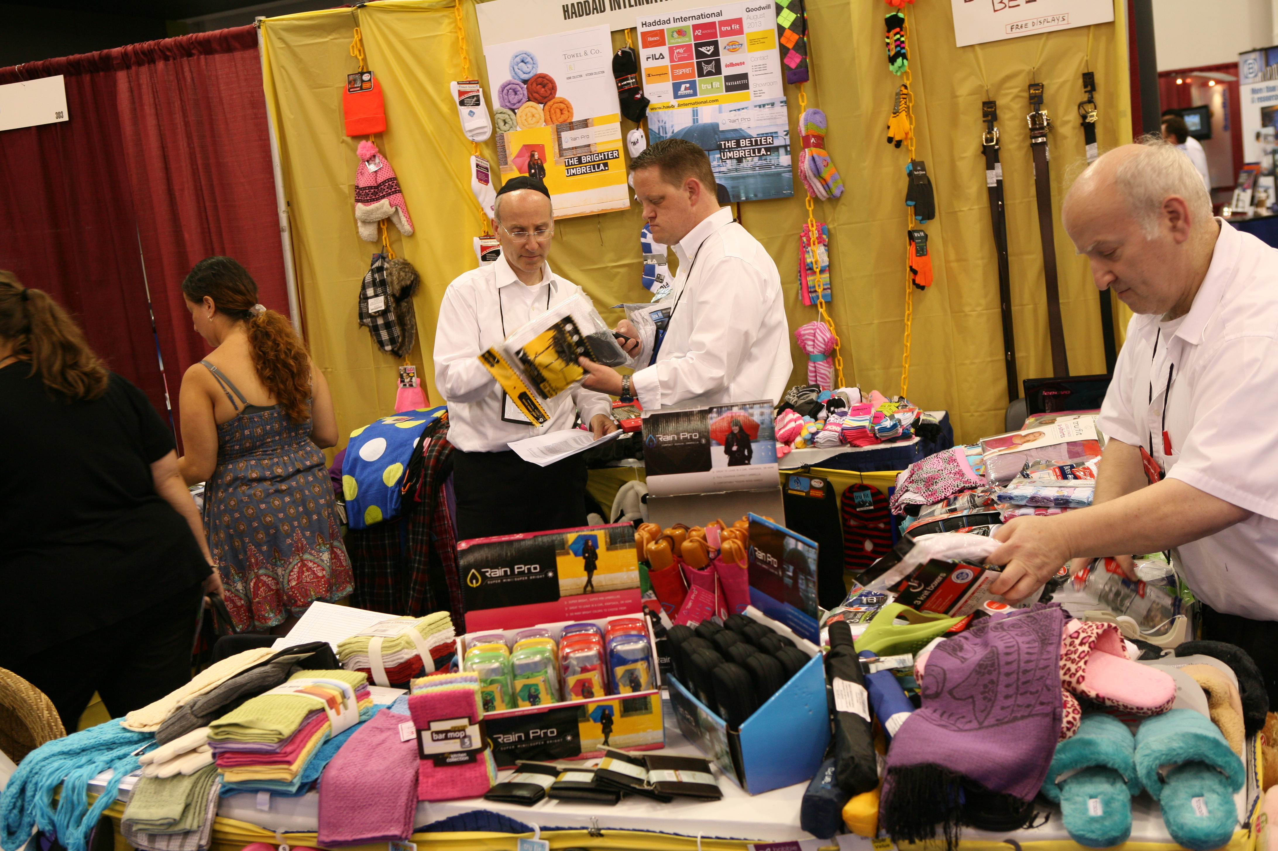
- Tabletop/Booth Audio Visual Equipment
- Tabletop/Booth Accessories
- Tabletop/Booth Material Handling (Labor, Shipping and Freight)
- The purchase of any custom marketing to increase exposure

Exhibits Terms and Conditions
Upon acceptance by GII, all Exhibitors are required to agree and comply with the following Terms and Conditions:
- INDEMNIFICATION
- The Exhibitor agrees to indemnify, hold harmless and defend GII and the hotel or facility and their respective members, officers, directors, agents and employees from and against any and all liabilities, damages, actions, losses, claims and expenses (inclusive of attorney’s fees) on account of personal injury, death, or damage to or loss of property or profits arising out of or contributed to by any act, omission, negligence, fault, or violation of a law or ordinance by the Exhibitor or its employees, agents, contractors, patrons and invitees.
- GII will cooperate fully, but cannot assume responsibility for damage to Exhibitor’s property, lost shipments either arriving or departing the premises, or moving costs. Any damage due to inadequately packed property is the Exhibitor’s own responsibility. If the exhibit fails to arrive, the Exhibitor will nevertheless be responsible for booth rental fee, and no refund will be made. Exhibitor should carry insurance against such risks.
- LIABILITY/INSURANCE
- The Exhibitor shall, at its own cost and expense, carry and maintain Comprehensive General Liability Insurance through companies satisfactory to Goodwill Industries International in a minimum amount of a $2,000,000 combined single limit.
- All such policies (except Workers’ Compensation) shall specifically state: “Named as additional insurer under above policies.” The additional names are: Goodwill Industries International, Inc.
- Each policy shall provide that it may not be canceled or changed without at least ten (10) days’ prior written notice to GII.
- GII shall furnish to exhibit facility a copy of the Exhibitor’s Certificate of Insurance evidencing such coverage prior to the commencement of services hereunder and shall continue to provide the exhibitor facility with subsequent Certificates of Insurance evidencing uninterrupted compliance with this insurance requirement until the termination of this agreement.
- GII will provide a security guard solely for the tradeshow location from tradeshow move-in through tradeshow tear-down hours; however, the furnishing of such security services shall not be construed as an assumption, obligation or duty of GII with respect to the protection of property of the Exhibitor.
- The Exhibitor is solely responsible for the protection of its property. Due to the tremendous value of exhibits, it is impractical and impossible for GII to insure the Exhibitor’s equipment against loss, theft, damage or breakage.
- Neither GII nor the hotel, nor any facility, nor any of its employees or representative(s), nor any representative of GII, nor any subcontractor will be responsible for any injury, loss or damage to the Exhibitor or the Exhibitor’s employees or property, however caused.
- REJECTED DISPLAYS
- GII determines the eligibility of any company or product for exhibit. GII may forbid installation or require removal or discontinuance of any exhibit or promotion, wholly or in part, that in its sole opinion is not in keeping with the spirit and mission of Goodwill.
- Unethical conduct, breach of this contract, or infractions of rules on the part of the Exhibitor or its representative(s), or both, will subject the Exhibitor or representative(s) to dismissal from exhibit areas.
In the event of such dismissal, no refund shall be made, and the Exhibitor or its representative(s) may make no demand for redress.
- Exhibitors and representative(s) who fail to observe these conditions of contract or who, in the opinion of GII, conduct themselves unethically may be dismissed without refund or appeal for redress.
- SPACE ASSIGNMENTS
- Space assigned to Exhibitor may be reassigned by GII to affect balance against congestion, to avoid confusion in company names, to solve competitive conditions, or for similar reasons.
- No such reassignment will be made without notification to the Exhibitor. An Exhibitor may not share with or sublet space to another party. If the Exhibitor has requested more than one booth space, GII will assign contiguous space if such space is available.
- The Exhibitor must conduct all its activities within its assigned booth space. The Exhibitor may not use the aisles or other areas of the exhibit hall for its promotional activities.
- HEIGHT AND SPACE RESTRICTIONS
- All in-line exhibits, back walls and decorations will be limited to eight (8) feet in height, not extending more than three (3) feet from the back wall, except actual equipment that in normal operation exceeds this height. Permission to exhibit equipment with abnormal heights must be obtained from GII.
- Exhibits should not project beyond the space allotted and should not obstruct the view or interfere with traffic to other exhibits. The wings of an exhibit should not project more than three (3) feet from the back wall.
- Exhibitors who assemble a display that does not meet these height and space restrictions or that obstruct sight to other Exhibitor booths will have their booths moved, rearranged or dismantled at the Exhibitor’s expense.
- SOLICITATION
- GII may, at its sole discretion, withhold or withdraw permission to distribute souvenirs, advertising or other material it considers objectionable. Novelty gifts or souvenirs must be submitted to GII for review prior to distribution.
- Direct selling of products or services is prohibited. The Exhibitor agrees that selling goods or services in the exhibition hall will result in the closing of the exhibit by GII. It is agreed that no refund of exhibit fees and no demand for redress will be made by the Exhibitor or its representative(s) in this event. No soliciting for business shall be permitted in aisles or in other Exhibitors’ booths.
- Exhibitor may distribute samples, catalogues, pamphlets, publications and promotional materials only within its own booth.
- No Exhibitor will be permitted to give away any premium items, or to conduct any prize drawings for awards for signing of names and addresses, or other extreme promotions, without first obtaining written permission from GII.
- Advertising, canvassing, solicitation of business, and other activities are not permitted in the exhibit hall except by companies that have obtained space to exhibit from GII, and then only in the space assigned.
- TRADEMARKS
Exhibitor’s use of GII’s name and its Smiling G logo or any other GII-owned trademarks is strictly prohibited in any advertising or marketing material on the web or in print or as part of the exhibit. The only logo permitted for use in tradeshow marketing material is the Goodwill Member Marketplace logo below, which will be available to exhibitors for download during registration.
- BOOTH MATERIALS/FIRE REGULATIONS
- All exhibit and booth materials must comply with federal and city fire laws, insurance underwriter, and hotel/facility safety regulations, and must be flameproof. All packing containers, excelsior and similar materials are to be removed from the exhibition area upon completion of booth set-up.
- The Exhibitor is restricted to materials that will pass inspection. Decorations of paper, pine boughs, leafy decorations, tree decorations or tree branches are prohibited. Any substance prohibited by the city fire and safety departments or authorities will not be permitted in the exhibition area. In addition, all electrical work and electrical wiring must be approved and installed in accordance with local regulations.
- Exhibits must not block aisles or fire exits. Any questionable materials, including helium, gas, etc., must be approved by GII.
- The Exhibitor will not be permitted to store packing crates, containers and boxes in its booth during the tradeshow period. The Exhibitor may make arrangements with the GII contracted exhibitor decorator or the facility for storage of packing crates, containers and boxes that are properly identified with the Exhibitor’s name. GII is not responsible for the damage, destruction or theft of any packing crates, containers or boxes.
- AUDIO AND VIDEO
- Motion picture projectors and apparatuses must conform to the fire regulations of the facility. Projection of motion pictures must be supervised by a licensed operator where required.
- An exhibitor with audible electric sound, motion pictures or other microphones or devices that GII, in its sole discretion, deems objectionable to other Exhibitors will be required to discontinue this method of promotion. GII reserves the right to impose sound limitations on Exhibitors when their promotional activities are interfering with the activities of other Exhibitors or participation and enjoyment of the exhibit hall by Goodwill members.
- BOOTH STAFFING
- In its best interest, and for security, the Exhibitor shall keep staff in the booth(s) during all exhibit hours. Each exhibiting company is entitled to up to two (2) exhibit staff badges per booth. An exhibit staff badge is for personnel responsible for working in the booth during show hours, and it will not provide access to any other event. Badges must be worn at all times for admission to the exhibit hall. Additional personnel and additional badges per booth can be obtained for $500 per person. This does not apply to sponsors.
- GII is not responsible for any loss or damage to Exhibitor’s display, materials, or other personal property left in the booth, whether the booth is attended or unattended.

- INSTALLING/DISMANTLING/REMOVING BOOTHS
- The exhibit hall will be available to exhibitors during the designated move-in hours for the installation of displays. All exhibits must be operational by the time the tradeshow opens. No installation will be permitted during the tradeshow hours without special written permission from GII. Space not occupied by tradeshow open may be reassigned for other purposes by GII. Any Exhibitor failing to occupy contracted space is not relieved of the obligation to pay for such space at the full rental price, and GII shall have the right to use such space as it deems appropriate to eliminate blank space in the exhibit hall.
- The exhibit hall will be available to exhibitors during designated move-out hours for the dismantling and removal of displays. Load-out of all booths must be completed by the designated times. No exhibit may be dismantled before the specified time, nor may any part of the exhibit or equipment be removed once it has been set up, without permission from GII.
- Before any exhibit may be removed from the building, the Exhibitor must make arrangements satisfactory to GII and the facility for payment of any charges incurred by the Exhibitor in connection with the exposition therein.
- The Exhibitor must surrender the booth space in the same condition it was in when the Exhibitor arrived. The Exhibitor and its employees and agents shall not damage or deface any part of the building where the tradeshow is held, the booths, or the equipment or furniture of the booth, or property of other Exhibitors.
The Exhibitor may not tape, nail or otherwise affix the exhibit or signs to the walls, doors or other components of the booth space of the facility in a way that might cause damage. The Exhibitor is liable to the owner of the property for any damage caused by the Exhibitor, its employees or agents. GII or the facility may remove any display, materials or other personal property left in the booth space after the designated move-out end times and neither GII nor the facility shall have any liability to the Exhibitor for the return of any property so removed or compensation for its value. The Exhibitor will be solely responsible for any charges incurred by GII or the facility in removing the Exhibitor’s personal property from the booth space.
- The Exhibitor will comply with all rules and regulations imposed by the facility on the use of hand trucks, carts or other vehicles for transporting displays and materials into and removing them from the exhibit hall.
- THIRD-PARTY CONTRACTORS
- All Exhibitors are strongly encouraged to use the contracted exhibitor decorator for booth exhibits.
- GII has selected and contracted an official exhibitor decorator for the tradeshow, with labor and equipment to be provided at prevailing rates. Contact information for the exhibitor decorator will be provided.
- Due to limited storage, large shipment of drayage, packages or exhibits for an exhibit and/or production company or client will not be accepted by the exhibit facility. A large shipment is roughly defined as any shipment with more than five boxes, or weighing in excess of 100 pounds. Should an Exhibitor send unqualified package(s), they will not be accepted by the receiving department. Please make arrangements for pre- and post-shipping, drayage handling and storage with the contracted exhibitor decorator.
- No deliveries can be made through the public areas of the hotel. Please deliver all materials through the shipping and receiving department.
- Small outgoing shipments may be handled by the facility.
- The Exhibitor assumes full responsibility for any third-party contractor hired by the Exhibitor.
- PAYMENT, CONFIRMATION AND CANCELLATION POLICY
- Exhibiting space will not be assigned without full payment.
- GII may not be able to accommodate all applicants. Companies that have applied to exhibit will be accommodated at the sole discretion of GII and will be notified as such.

- Any Exhibitor may cancel or withdraw from exhibiting at the tradeshow subject to the following conditions:
- The Exhibitor shall give GII written notice of cancellation. Such notice will be considered official on the date of receipt by GII.
- Written cancellations received prior to cancellation deadlines will be honored with a full refund, less a $100 processing fee.
- After cancellation deadlines, no refund shall be given for cancellations or no-shows. The Exhibitor assumes the risk of transportation, delivery, contractor and other delays that may prevent the Exhibitor or its display from arriving on time at the tradeshow.

- In the event the premises of the facility are destroyed or damaged, or if the tradeshow fails to take place as scheduled or is interrupted or discontinued, or access to the premises is prevented or interfered with by reason of any strike, lockout, injunction, act of war or terrorism, act of God, emergency declared by any government agency, or for any other reason, GII may terminate the tradeshow. In the event of such termination, the Exhibitor waives any and all damages and claims for damages and agrees that the sole liability of GII is to return to the Exhibitor its space fee payment after payment of all tradeshow expenses.
- AMERICANS WITH DISABILITIES ACT (ADA)
- All Exhibitors shall be responsible for complying with the accommodations or requirements of the ADA, including:
- The readily achievable removal of physical barriers to access the assigned exhibit and common areas.
- The provision of auxiliary aids and services where necessary to ensure that the Exhibitor treats individuals with disabilities no differently than other individuals.
- The modification of the Exhibitor’s policies, practices and procedures applicable to all guests and/or groups as necessary to provide goods and services to individuals with disabilities.

- The Exhibitor shall indemnify and hold harmless GII against all losses, liabilities, claims, suits, expenses and damages, including attorney’s fees, on account of or relating to any actual failure of the Exhibitor to comply with local, state and/or federal laws regarding ADA accommodations.
- AMENDMENT TO RULES
- Any and all matters or questions not specifically covered by these Terms and Conditions shall be subject solely to the discretion of GII.
- GII may, in its sole discretion, make reasonable changes, amendments or additions to these terms and conditions. Any such changes shall be binding on the Exhibitor equally with the other Terms and Conditions contained herein.

